Medical Assistant Chatbot (Med Bot)

***Abstract*— Now-a-days, a working human being may neglect certain health condition which may cause or lead to over time or start a long term disease. A person may also unessentially worry about having a serious health issue and be conscious about it. This system will be an alternative to the conventional method, which is probably followed now-a-days, that is to visiting a hospital/clinic and making an appointment with the doctor to get checked/diagnosis. A Chatbot can be used as a communicating interface between them just like we communicate with other humans with several queries. Chatbot can take patients symptom’s and predict the probable disease.**

***Keywords*—Deep Learning, KNN, SVM, Machine Learning, Medical Assistant Chatbot.**

1. Introduction

Human is expert in understanding information, while machine is expert at expressing and processing data. Artificial Intelligence made computer more intelligent and can enable the computer to think. Computers provide us with information, keep us entertained, and assist us in many ways. AI study considers machine learning as subfield in numerous research works. [2] One of the many machine learning applications is utilized to construct such classifier that can separate the data based on their characteristics. [2] Different analysts feel that without learning, insight can't be created. A chatbot is a software program of a conversational interface that allows a user to converse in the same manner one would address a human. Conversational bots are used in almost every customer interaction, like instantly messaging the client. A chatbot is a computer programme designed to mimic intelligent speech or text conversation. The need for a reliable and accurate diagnosis wakes the rise of a new generation of healthcare technology called the Medical Chatbot. The main idea of creating this chatbot is to replicate a person’s discussion. [1] This helps people to learn more about their symptoms and give them the most accurate diagnosis possible.

A medical chatbot is built to be a conversational agent that motivates users to discuss about their health issues and based on the symptoms provided by them and Chatbot returns the diagnosis. This chatbot system will be able to identify symptoms from user interaction. Using these extracted symptoms Chatbot predicts the disease and recommends treatment.

Implementing the model can raise people's awareness of their health condition and the need to take measures to stay healthy. Health chatbots may speed up processes which means more free time and usefulness for both patients and healthcare professionals. Also, they may prevent activities that take up too much time for people and bring a minimal outcome (going to the doctor).

II. LITERATURE REVIEW

D. Madhu, C. J. N. Jain, E. Sebastain, S. Shaji and A. Ajayakumar, [1] developed an artificial intelligence-based model that enables people to find the best cure for their ailment. Every condition has a variety of therapies available, thus it is impossible for anyone to know which one is best for them. The main responsibility in this proposed approach is given to artificial intelligence, which compiles a list of remedies that are now available depending on the ailment that has been determined from the symptoms. In order to aid users in choosing the best course of treatment, the system can also list the ingredients of medications and their recommended usage. Having a rudimentary understanding of one's health status thanks to this method motivates one to seek appropriate medical attention.

D. Dahiwade, G. Patle and E. Meshram [2] proposed a broad machine learning algorithm-based disease prediction system. Because medical data is expanding rapidly today and must be processed to make precise disease predictions based on symptoms, KNN and CNN algorithms are used to identify patient data. By using patient records as input, which aid in understanding the level of illness risk prediction, it is possible to produce an output that was correct in terms of general disease risk prediction. This approach may provide disease and risk prediction with the least amount of effort and expense possible. When compared the outcomes of the KNN and CNN algorithms in terms of accuracy and processing time, it is found that CNN has higher accuracy than KNN and that CNN requires less processing time per classification than KNN. So, in terms of accuracy and timing, CNN is superior to KNN.

R. B. Mathew, S. Varghese, S. E. Joy and S. S. Alex [3] describes a medical chatbot that can be used to diagnose illnesses and make treatment recommendations in place of the current system. A chatbot can serve as a physician. As a user application, the chatbot serves users. The chatbot in this application allows users to describe their symptoms, and the chatbot then recommends the appropriate health actions. The chatbot instance may advise the user about ailments and treatments because general information about symptoms and diseases is present in the dataset. After examining the symptoms of the many users, it finally diagnoses the user's condition and gives a link to information about the available treatments. Additionally, one of the main benefits for users of chatbots is their cost-effectiveness. Users are encouraged to be more forthcoming about their health issues thanks to the entirely private chats with users, which also makes it easier for chatbots to accurately diagnose diseases.

P. Zhang, X. Huang and M. Li [4] have proposed to achieve the initial disease prediction and early management; it suggests a methodology for analyzing patient symptom similarity. In order to generate the sentence vector and reduce the size of the sentence, the model makes use of a convolution neural network to extract the key information, such as the patient's symptoms and sentiments, from the patient's descriptive sentences. Primary innovations in this are the preprocessing of texts and the similarity score calculation. First, the SPO model is used to collect symptoms data for the neural network's input, which is crucial for reducing the model's computational load and efficiently extracting the main pathological features. Second, the Manhattan distance formula is employed to compare the outcomes of the disease prediction model's sentence vector output.

Andrew Reyner ibowo Tjiptomongsoguno, Audrey Chen, Hubert Michael Sanyoto, and Bayu Kanigoro [5] in their work covers every study that was relevant to chatbots, particularly those that were used in medicine. After studying throuoghly, it is discovered how to create a chatbot, what sort of algorithm it employs, and how to obtain the data set needed to train the chatbot. As it is seen, there are numerous methods that can be used to create a chatbot, including data mining, natural language processing, machine learning, Braun and Clarke's algorithm, and compare keywords. It is seen that from those methods machine learning and natural language processing are the most suitable for use in chatbots. Major papers handle user input, which is typically represented as a string, using natural language processing techniques so that the software can understand it. The architecture or the programme cannot process the raw input (string). The NLP approach converts the common string format into a tokenized format. As opposed to the string format, the tokenize format is simpler for the application to process. When user inputs are tokenized, machine learning techniques like classification can be used to process the symptoms and match them to the diseases that are present in the classification training. NLP and machine learning are hence the algorithms that, in our opinion, are best appropriate for creating chatbots.

J. E. Zini, Y. Rizk, M. Awad and J. Antoun [6] designed a virtual presence (VP) or specialized chatbot, both terms used interchangeably throughout the book, for OSCEs capable of engaging with students and providing them with answers based on deep learning. It concentrates on the NLP engine that enables communication between the avatar and the medical student. Convolutional neural networks (CNN) and long short-term memory (LSTM) networks specifically learn domain-specific word embedding, sentence embedding, and answer selection models. Because this method does not necessitate explicit language analysis, it is easier for system engineers to create features that are appropriate for QA systems. A corpus of medical documents served as the training data for the embedding’s model. On a self-created dataset of QA pairings, an answer selection accuracy of 81% was attained. This method beat earlier VPs that were limited to a single pharmacological environment, relied on manually generated semantic resources, and had significant mistake rates.

Amela Softić, Jasmina Baraković Husić, Aida Softić and Sabina Baraković [7] proposed the development and deployment of a health chatbot application, as well as a study of end-user surveys to determine its acceptability and driving factors for use. The suggested health chatbot is designed to quickly evaluate symptoms and risk factors for those who are worried about their health and offer advice and information for next measures. The health chatbot application is not a substitute for a real doctor because there are so many diseases with similar symptoms. This application can only be used to encourage the patient to consider their symptoms seriously and get help from a doctor. Due to the fact that this chatbot is arbitrary and only exists to inform the patients about their health state, there is no legitimate foundation for lawsuits in the event of a poor health outcome.

G Krishna Vamsi, Akhtar Rasool and Gaurav Hajela [8] discovered according to studies, neural networks and various algorithms can help chatbots operate better. The chatbot could be made better by making a voice version available, which assists those who are blind or illiterate. It is crucial to understand the limits of the chatbot, such as the correctness of the model, the lack of empathy, and privacy concerns about user data. While chatbots may do a variety of activities, they will never be able to completely replace people until they can comprehend human perception and emotions. In the medical field, this is much truer.

Lekha Athota, Vinod Kumar Shukla, Nitin Pandey and Ajay Rana [9] designed the application to deliver high-quality responses quickly. By using an expert system to give the response directly to the user, it relieves the burden from the answer source. The project was created for the user to save them time when seeking medical advice from doctors or specialists. Here, an application is created that extracts the keyword from the user query using the N-gram and TF-IDF. Each term is given less weight in order to get the right response to the query. The web interface was created with users' input queries in mind. By providing user protection, character integrity, and retrieving answers in line with the questions, the application is strengthened in terms of security and efficacy.

Prathamesh Kandpal, Kapil Jasnani, Ritesh Raut and Prof. Dr. Siddharth Bhorge [10] after developing chatbots, have gained a brief understanding of the field of virtual assistance and how it will affect our lives in the future. After examining the current research and advancements businesses and other organizations are making in this area, it is clear that chatbots will play a significant role in both large and small businesses as well as other organizations. The several packages that must be installed, the code workflow, creating data in the intents file, training the model, and obtaining meaningful output were all covered here. And also discussed the many business uses for chatbots, pertinent tasks, typical difficulties, and its limitations.

III. PROPOSED MODEL

Figure 1: Flowchart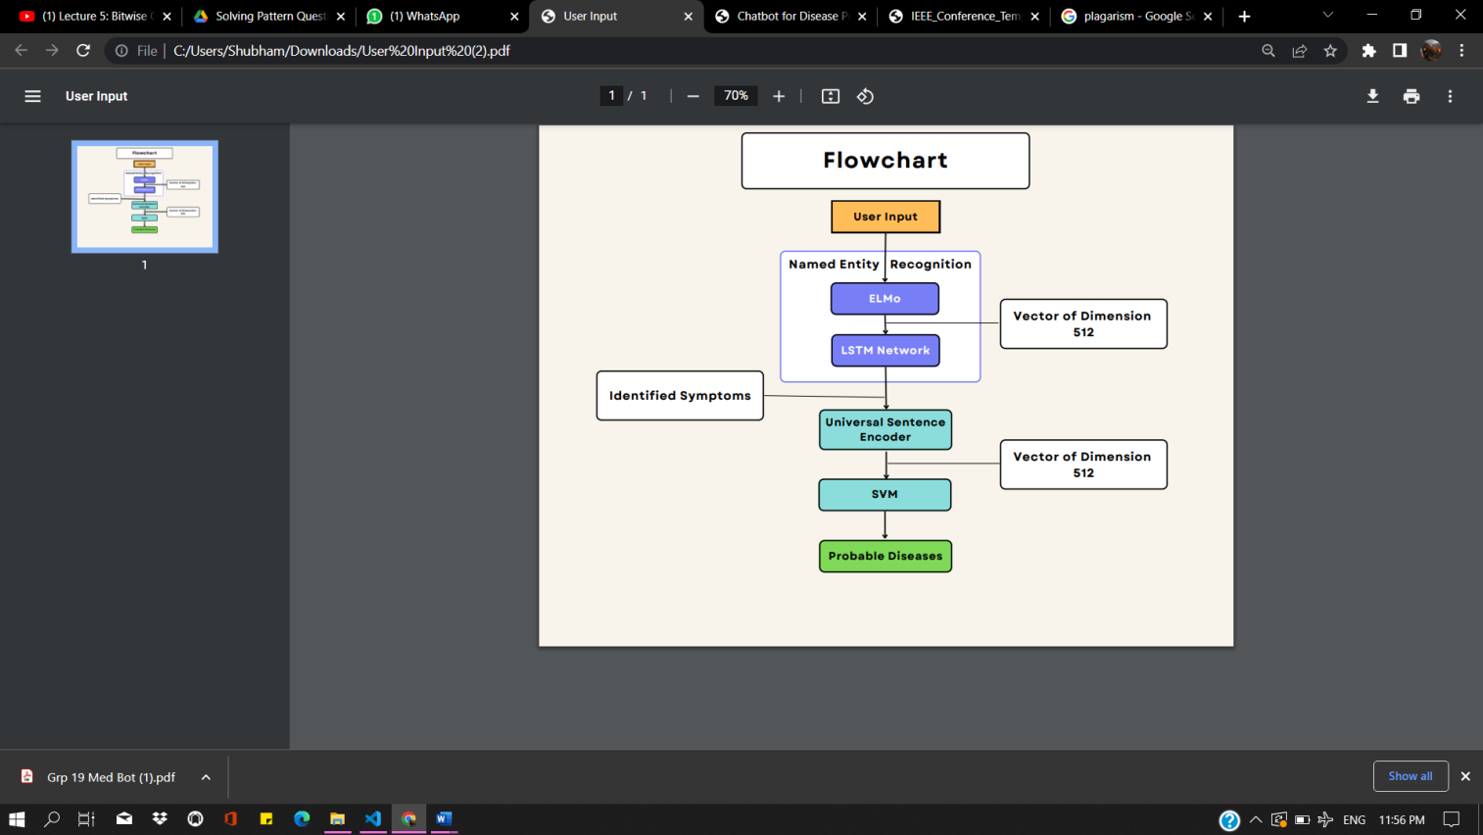

A List of symptoms keywords is made by extracting them from the disease-symptoms dataset. The sentences containing the words which are part of this list are fetched. Some of these fetched tweets contain the words which are the symptoms but they don’t relate about the disease, so such sentences are eliminated in order to improve consistency. The emoji’s with repeated sentences keywords are cleaned by using the python’s regular expression function regex().

Each sentence contains words which represent a symptom or continuation of symptom or non-symptom. Each symptom in this dataset is given a label ‘b-sym’ indicating the starting of the symptom and ‘c-sym’ indicating the continuation of the symptom, rest of the other words of the sentence are given the tag ‘o’. These labels are assigned in order to train our symptoms recognition model to differentiate the words in these three categories, so that when an end user explains his suffering to the medical chatbot the chatbot is able to differentiate the words in the above mentioned categories.

Recognizing Symptoms through Named Entity Recognition (NER) The sentences are passed through Embedding’s from Language Models (ELMo) in order to assign the mathematical value to each word, thus to generate the vector of dimension 512. The ELMo model computes contextualized word representations using character based representations and bidirectional LSTM network. These vectors and their labels are passed through the Long Short Term Memory network, in order to train the model to recognize the symptoms present in the sentence entered by the user.

This LSTM network consists of three bidirectional LSTM layers (Activation Layer, Forward Layer and Backward Layer) each having 256 neurons and a 512 neuron dense layer. Softmax activation (it is often used as the last activation function of a neural network to normalize the output of a network to a probability distribution over predicted output classes) is used here as there are multiple classes (b-sym, c-sym, o).

sof tmax(zi) = exp(zi)

P j exp(zj) (1) 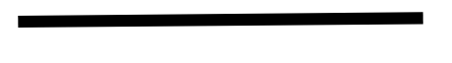

Here ‘z’ is the value of the neuron from the output layer.

After the training of the model, the symptoms are passed to Universal Sentence Encoder which is the next phase of the system.

Processing the recognized symptoms via Universal sentence encoder the recognized symptoms received from the LSTM network are pre-processed. Lemmatization will be used in this step. Using lemmatization a word can be reduced to its base form For example: Words like Laughed, laughs would be reduced to “laugh” after lemmatization. These pre-processed symptoms are passed through Universal Sentence Encoder, which encodes these symptoms into a vector of dimension 512. Universal Sentence Encoder comes in two variations i.e. Deep Averaging Network (DAN) and Transformer encoder. We have used Deep Averaging Network variation of Universal Sentence Encoder as it is computationally less expensive. The vector of dimension 512 generated by the Universal Sentence Encoder is then passed to Support Vector Machine.

Mapping the unique vector obtained by universal sentence encoder to a disease in the dataset. There are many methods to perform the task of mapping the set of symptoms entered by the user to the disease based on the training of the model. They are Cosine Similarity, KNN, Manhattan Distance, Support Vector Machine. With SVM, it give’s three top most probable diseases, the user may be suffering from based on the symptoms entered by him/her.

IV. Algorithm

1. KNN

The K-Nearest-Neighbors (KNN) approach does not make any assumptions about the elementary dataset because it is a non-parametric classification algorithm. It is renowned for its efficacy and simplicity. It is an algorithm for supervised learning. An identified training the data points are in a dataset that is provided. Various classes have been established so that the class of data without labels can be expected.

Usually the value of K is based on the data, makes parameter selection difficult according to different applications. Introducing a new metric to measure informational characteristics of the classified objects. Calculate information measures the importance of points. In this method, there are two input parameters K and I. The Most Informed Grade the training examples will be the class of the new test taste.

1. SVM

The support vector machine (SVM) is a classification technique applied on linear as well as nonlinear data. It is a composite version of KNN combined with SVM for image catalog recognition and is increased in. [7] In this algorithm, training is done with the help of the nearest K the neighbors of the data point are not labeled. First, K- nearest data points are determined. Then pair the distance between these K data points is calculated. Hence, we get a distance matrix from the calculation distance. The Kernel matrix is ​​then designed from distance matrix is ​​obtained. This core matrix is ​​provided as input to the SVM classifier. The result is the class of the data point is unknown. In addition, a can use SVM but time consuming is one of the defect. It also involves calculation pair distances.

V. RESULTS AND ANALYSIS

The end result of this project is as follows: in order to receive the specific disease, a user must engage in text-to-text dialogue with the chatbot. Users may also access their past chat history by entering their database-stored information.

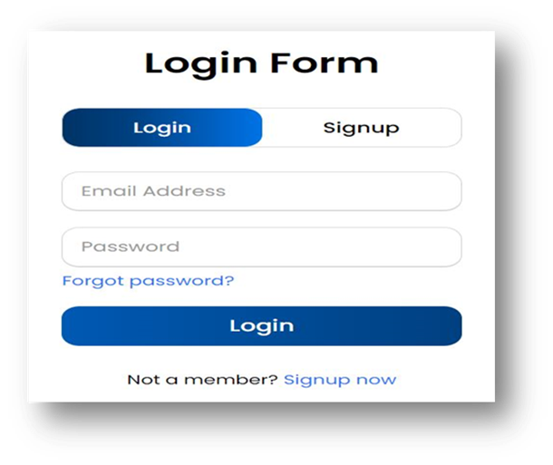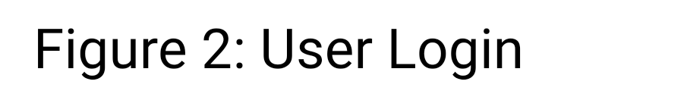

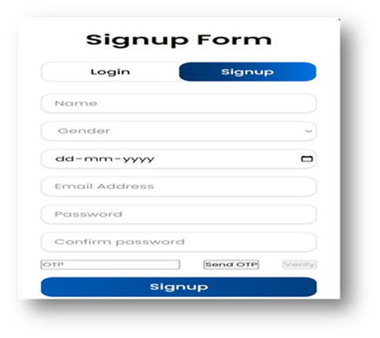

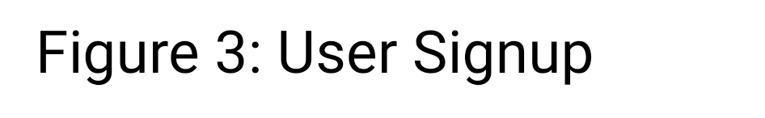

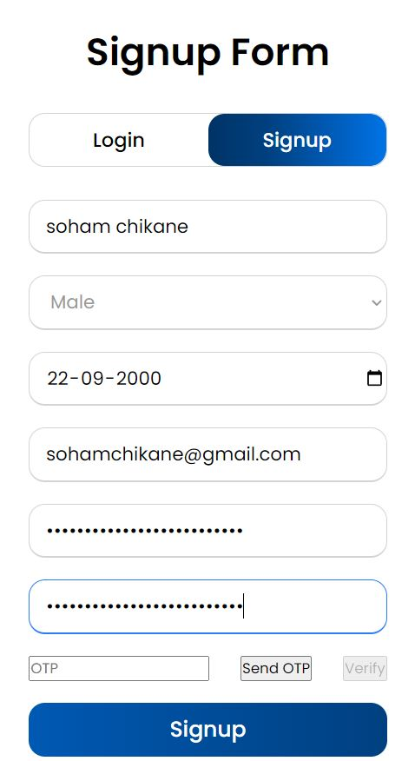

Figure 4: User Signup Details

The above figure shows the user interface of our medical assistant chatbot. Any new user will first register or signup with all their details and then he/she can login.

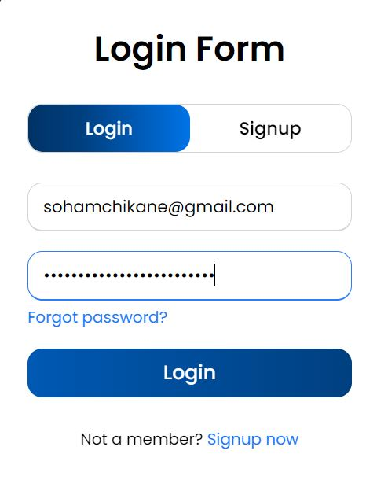

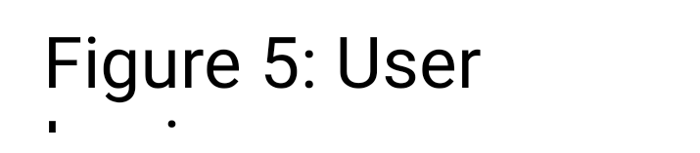

The user will now login to have a conversation with the medical chatbot. Recurrent user will directly login.

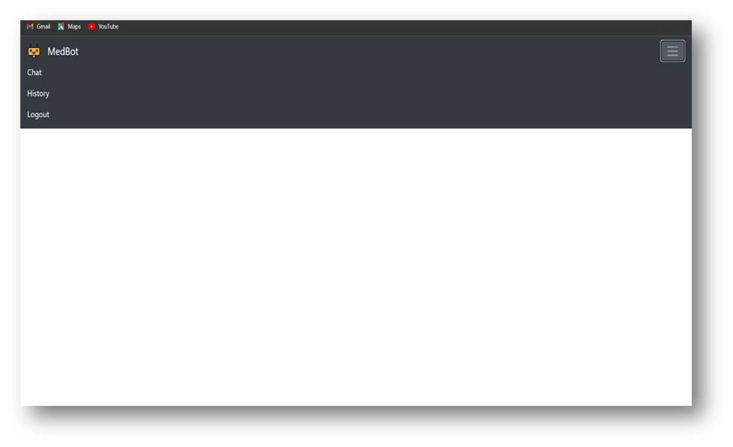

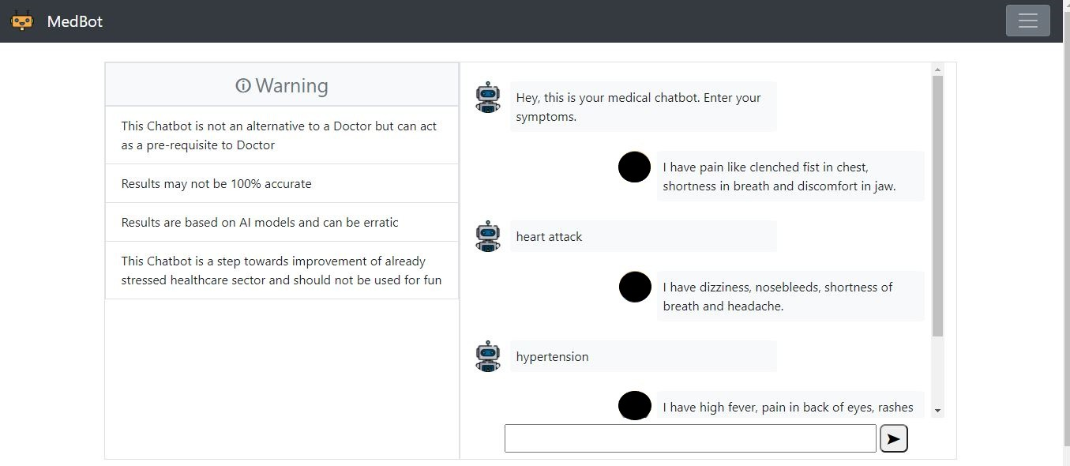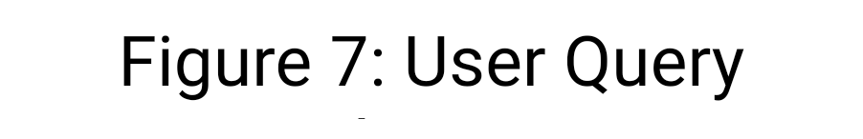

The medical chatbot is interacting with the user based on the symptoms entered.

VI. CONCLUSIONS

This paper explains a medical chatbot which can be used to replace the traditional method of disorder diagnosis and remedy recommendation. Chatbot can act as a doctor. The chatbot acts as a consumer utility. The person of this utility can specify their signs and symptoms to the chatbot and in flip, chatbot will specify the fitness measures to be taken. Popular data about symptom and sicknesses are to be had within the dataset and hence the chatbot example can offer information about ailment and remedy to the consumer. After reading the symptoms of the unique users, it in the end predicts the sickness to the person and provides with a link where information about the treatment is seen. A clever medical chatbot can be useful to patients via identifying the signs as defined via them, giving proper prognosis and providing with appropriate treatment for the disease. Inside the busy life, it is rare for human beings to regularly go to hospitals for take look at-ups. Chatbot is of awesome importance in such conditions as they provide diagnostic help with a unmarried click of button. Chatbot doesn't require the assist of any medical doctor to give right health measures to the customers and that is one of the predominant benefits of chatbot. Moreover, the cost-effectiveness in using chatbot is a prime beauty to customers. The chat with users is completely non-public and this facilitates users to be more open with their health matters and paves manner for chatbot to efficaciously pick out the disorder.

VII. FUTURE SCOPE

The function performed by means of chatbot can now and again be past the scope and person might also require consulting a physician for taking health associated checks. In such situations, chatbot may be helpful if it may be made to installation an appointment with a green doctor based totally on their schedule. Also it will likely be useful if the signs and sickness diagnosed with the aid of the chatbot can be made into a file and robotically forwarded to an available health practitioner in which he can in addition assist the person with greater advices and destiny measures to preserve their health. A video call with a specialized doctor also can be made relying at the availability of the person rather than primarily based at the availability of medical doctors.

VIII. REFERENCES

1. D. Madhu, C. J. N. Jain, E. Sebastain, S. Shaji and A. Ajayakumar, “A Novel Approach for Medical Assistance Using Trained Chatbot”, 2019 International Conference on Inventive Communication and Computational Technologies (ICICCT), Coimbatore, 2019, pp. 243-246.
2. D. Dahiwade, G. Patle and E. Meshram,” Designing Disease Prediction Model Using Machine Learning Approach”, 2019 3rd International Conference on Computing Methodologies and Communication (ICCMC), 2019, pp. 1211-1215, doi: 10.1109/ICCMC.2019.8819782.
3. R. B. Mathew, S. Varghese, S. E. Joy and S. S. Alex, “Chatbot for Disease Prediction and Treatment Recommendation using Machine Learning”, 2019 3rd International Conference on Trends in Electronics and Informatics (ICOEI), Tirunelveli, India, 2019, pp. 851- 856.
4. P. Zhang, X. Huang and M. Li, “Disease Prediction and Early Intervention System Based on Symptom Similarity Analysis”, in IEEE Access, vol. 7, pp. 176484-176494, 2019, doi: 10.1109/ACCESS.2019.2957816.
5. Andrew Reyner ibowo Tjiptomongsoguno, Audrey Chen, Hubert Michael Sanyoto, and Bayu Kanigoro, “Medical Chatbot Techniques: A Review”. Springer Nature Switzerland AG 2020. R. Silhavy et al. (Eds.): CoMeSySo 2020, AISC 1294, pp. 346–356.
6. J. E. Zini, Y. Rizk, M. Awad and J. Antoun, “Towards A Deep Learning Question-Answering Specialized Chatbot for Objective Structured Clinical Examinations”, 2019 International Joint Conference on Neural Networks.
7. Amela Softić, Jasmina Baraković Husić, Aida Softić and Sabina Baraković, “Health Chatbot: Design, Implementation, Acceptance and Usage Motivation”, 20th International Symposium INFOTEH JAHORINA (INFOTEH), IEEE 2021, 978-1-7281-8229-2/21, DOI: 10.1109/INFOTEH.
8. G Krishna Vamsi, Akhtar Rasool and Gaurav Hajela, “Chatbot - A Deep Neural Network Based Human to Machine Conversation Model”, 11th International Conference on Computing, Communication and Networking Technologies (ICCCNT), 2020.
9. Lekha Athota, Vinod Kumar Shukla, Nitin Pandey and Ajay Rana, “Chatbot for Healthcare System Using Artificial Intelligence”, 2020 8th International Conference on Reliability, Infocom Technologies and Optimization (Trends and Future Directions) (ICRITO) Amity University, Noida, India. June 4-5, 2020, 978-1-7281-7016-9/20.
10. Prathamesh Kandpal, Kapil Jasnani, Ritesh Raut and Prof. Dr. Siddharth Bhorge, “Contextual Chatbot for Healthcare Purposes (using Deep Learning)”, 2020 Fourth World Conference on Smart Trends in Systems, Security and Sustainability (WorldS4).